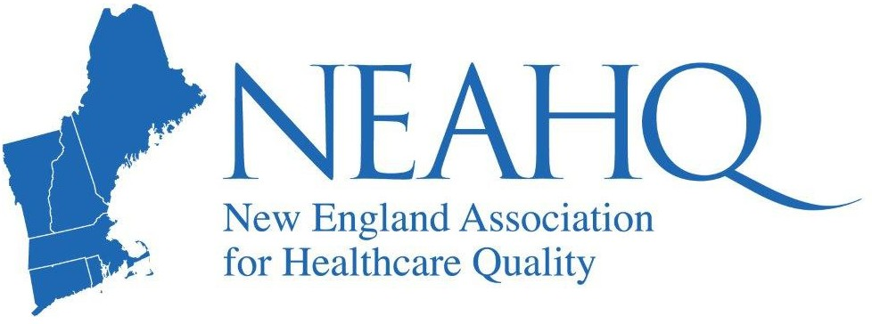

Public Reporting, Pay-for-Performance, and Hospital Rankings
WEBINAR
Dr. Calderwood will review CMS quality programs targeting inpatient and ambulatory quality and discuss what these programs can tell us about local opportunities for improvement.
Objectives:
Participants will be able name 3 pay-for-performance metrics
Participants will be able to identify opportunities for improvement based on data from CMS pay-for-performance programs
Participants will be able to state 2 limitations of federal pay-for-performance programs

Wednesday

April
24th
1pm EDT

About the Speaker:

Michael S, Calderwood, MD, MPH
Chief Quality Officer
Dartmouth Hitchcock Medical Center.

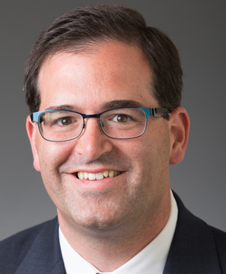

FREE event for members of NEAHQ
FREE event for members of MAHQ, OrAHQ, NCAHQ, FAHQ, AzAHQ, GAHQ, OAHQ, TGCAHQ by selecting your association's ticket type and using discount code provided by your association
$15 for Non-Members
Click here for more details and to register

