Criminalizing Medication Errors: Protecting Your Reporting Systems
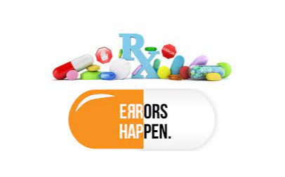

Many healthcare workers are unsure of what qualifies as an ‘incident’ that needs to be reported. Some feel that if it doesn’t cause patients harm, why report it? Conversely, many do not report because they don’t want to ‘tattle’, get in trouble, get sued, fired or ‘make a big deal about nothing’ because the patient didn’t get hurt.
Won’t all these issues impact reporting?
Join Maryann Shafou, CNO and Linda Weirauch, MDQM on Wednesday, December 28, 2022 from 12 pm to 2 pm for a robust discussion about litigation and convictions related to medical errors. Their presentation will also discuss Just Culture and how attendees can assess their own culture for reporting. Maryann and Linda will also share tools and processes that attendees can utilize in their own organizations to educate and improve confidence in the reporting process, all with the ultimate goal of improving patient safety and outcomes.

This program has been approved by the National Association for Healthcare Quality for a maximum of 2 CPHQ continuing education credit for this event.

