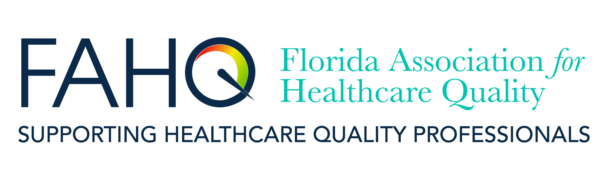 |  | FAHQ Live Webinar:  Thursday, September 29, 2022  12:00-1:00 PM EDT
Staying afloat in the wake of the COVID 19 Pandemic:
Emotional Intelligence is a critical life preserver.
In 2021, Dr Weiss presented a FAHQ webinar titled “What is Emotional Intelligence, why do healthcare workers need it, and how can it be improved?” This webinar is a follow-up requested by many attending that webinar, with an overall update linked to what we learned during the pandemic.  This webinar provides an overview of emotional intelligence (EI). The defining characteristics and components for measurements will be discussed. Additionally, the impact EI has on factors that affect healthcare quality and patient safety will be explored. Additional consideration and discussion are given to challenges faced in the wake of the COVID-19 pandemic.  Program Fee:  - FREE for FAHQ, AzAHQ, GAHQ, MAHQ, NEAHQ, NCAHQ, and OrAHQ Members  - $30.00 for Non-Members  CE Credit:  - 1.0 hour – FAHQ is a Florida Board of Nursing approved provider (Provider #50-17380)  - This program has been pre-approved by NAHQ® for 1.0 hour of CPHQ recertification CE credit.  REGISTER HERE:  FAHQ Webinar Registration  To receive FAHQ member rate (FREE), FAHQ members will need to log in on the registration page.  Healthcare Quality Coalition members should email webinars@fahq.org for a coupon code to register at the member rate. If you have registered for other FAHQ 2022 webinars, use the same code. | 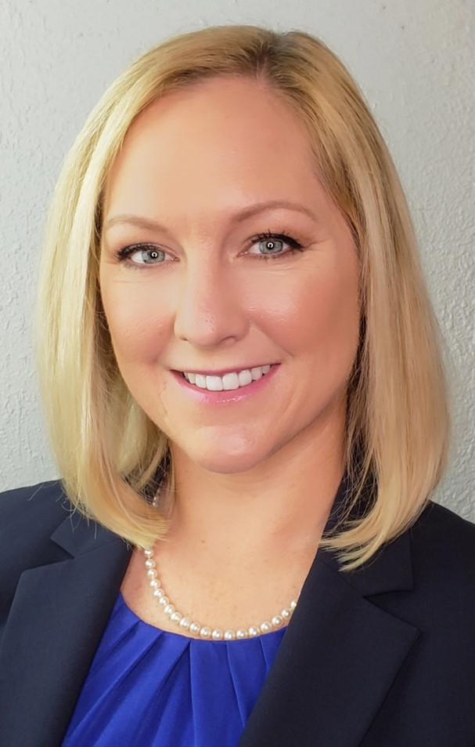  Speaker:  Sandy S. Weiss, DBA, MBA-HCM, RN, CPHQ, CPPS, CSM, PMP  Adjunct Faculty- Healthcare Management, Muma College of Business, University of South Florida, Tampa, Florida  Dr. Weiss is a Registered Nurse with a passion for all things healthcare! She teaches a variety of management courses for the University of South Florida’s Muma College of Business at the undergraduate and graduate levels. She most recently served as the Division Director of Quality for a large for-profit healthcare system, where she led clinical quality and regulatory compliance initiatives within the ambulatory care setting (>70 physician practices). She has robust experience across the healthcare continuum, from co-founding a companion care company, working on CMS contracts (CCSQ & CMMI), to leading in the acute care and inpatient rehabilitation settings. Dr. Weiss earned her Doctor of Business Administration and Master of Business Administration with a Concentration in Healthcare Management from Saint Leo University. Her dissertation focused on Registered Nurse emotional intelligence, turnover intention, and job performance. Her most recent publication, a collaboration with colleagues at USF and HCA West Florida Division Pharmacy, explored the relationship between Pharmacist emotional intelligence, occupational stress, job performance, and psychological affective wellbeing. A publication on Pharmacist resilience and burnout is currently in the works! Dr. Weiss is a Certified Professional in Healthcare Quality (CPHQ), a Certified Professional in Patient Safety (CPPS), Certified Scrum Master (CSM), and Project Management Professional (PMP). She also holds a graduate certificate in Innovation and Human Centered Design from The Johns Hopkins Carey Business School and is an AHRQ TeamSTEPPS Master Trainer.
Healthcare Quality Coalition webinars are presented by these state associations:
- Arizona Association for Healthcare Quality  - Florida Association for Healthcare Quality  - Georgia Association for Healthcare Quality  - Michigan Association for Healthcare Quality  - New England Association for Healthcare Quality  - North Carolina Association for Healthcare Quality  - Ohio Association for Healthcare Quality  - Oregon Association for Healthcare Quality |  |  | 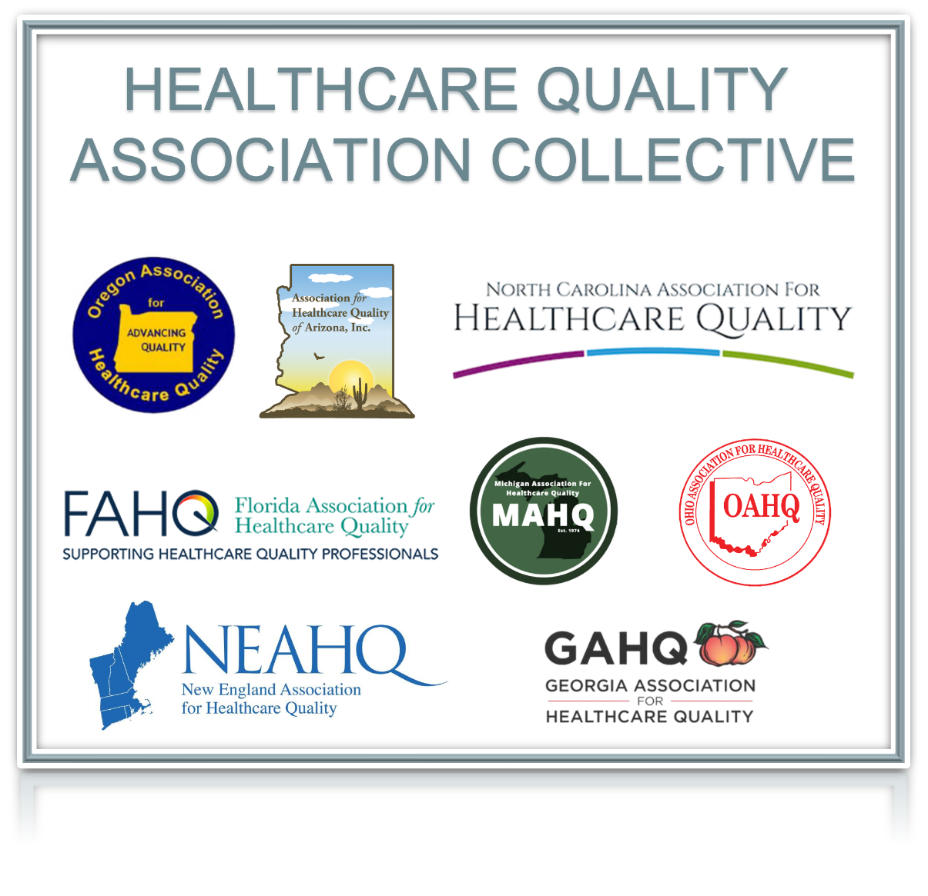
Please go to our FAHQ Webinar Page for more information on this and other FAHQ/HQC webinars.

