University of Tampa Parking Map for FAHQ October 21, 2022
Parking as a campus visitor with an approved parking pass is available in the West Parking Garage next to the Martinez Athletic Center. Please be aware of signs designating available visitor parking.
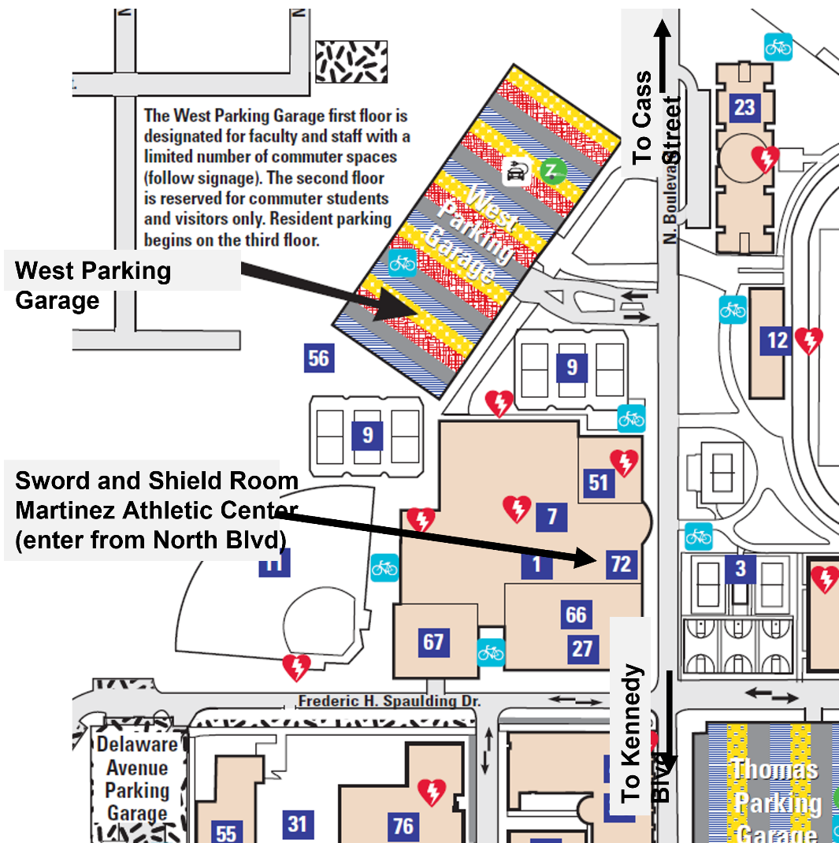

To request your parking pass:
Go to the Campus Safety Visitor Pass Form and complete the required fields. For “Name of UT person being visited or Event Attending enter “FAHQ Annual Conference – Dr. Rebecca Olsen.”
It is recommended you submit your request about a week before the event. You will receive an email from Campus Safety that your request has been submitted and will then receive the approved parking pass by email with instructions for use when arriving on campus.

