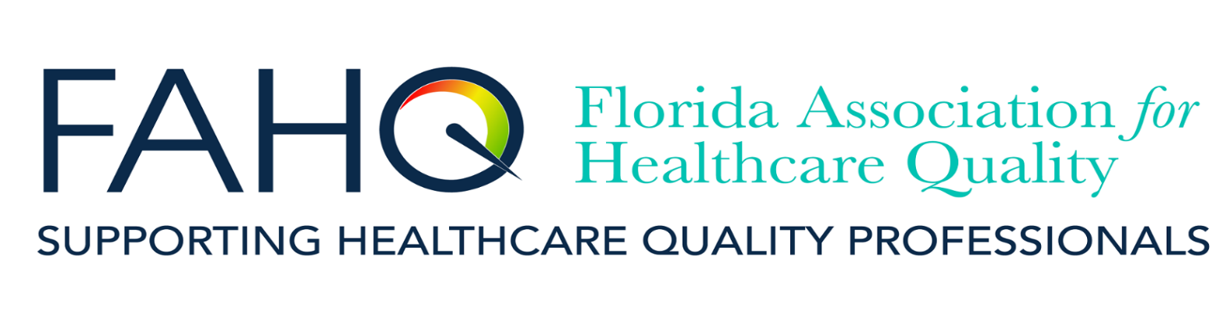
FAHQ Presents:  Effective Event Investigations and RCAs  May 18, 2022  12:00 – 1:00 PM EDT | Program Fee: FREE for Healthcare Quality Collective Organizations:  AzAHQ, FAHQ, GAHQ, MAHQ, NEAHQ, NCAHQ & OrAHQ Members  $30.00 for Non-Members  Registration Deadline:  May 16, 5:00 PM Eastern Time  To register or for more information:  FAHQ Webinars  Select Education, then Webinars
FAHQ is presenting this webinar as part of our participation in the Healthcare Quality Collective, a webinar collaborative and is pleased to offer this webinar free to our members and those of the HQC associations!
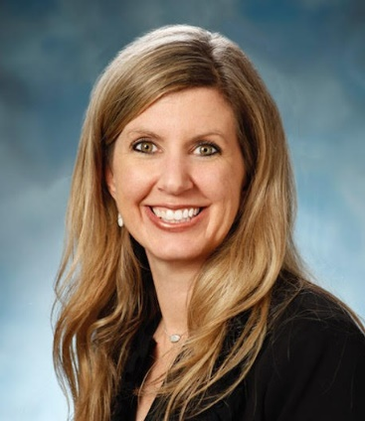
This program is designed to increase awareness of common pitfalls of event investigation and RCA management. It will include a review of tools and techniques for conducting effective interviews and steps to standardize your RCA process to execute more impactful RCAs.
Presenter: Myka Whitman, MHL, BSN, RN, CPHRM, CPPS, CPHQ
Senior Patient Safety and Risk Solutions Consultant
MedPro Group, Southeast Division
At the conclusion of this presentation participants will be able to:
- Identify common pitfalls of event investigation
- Gain tools and techniques for conducting effective interviews after an adverse/safety event occurs
- Identify methodologies and techniques that will lead to more operational and efficient RCAs
- Apply concepts in personal work settings
FAHQ is a Florida Board of Nursing approved provider (#50-17380). This webinar is approved for 1.0 hour CE credit, applicable to the following Florida licensing entities: Florida Board of Nursing, Florida Board of Respiratory Care, Council of Dietetics and Nutrition, and Council of Licensed Midwifery. Pre-approval requested from the National Association for Healthcare Quality for CPHQ recertification credit.

