**Florida Association for Healthcare Quality**

**2019 Annual Conference and Exhibition**

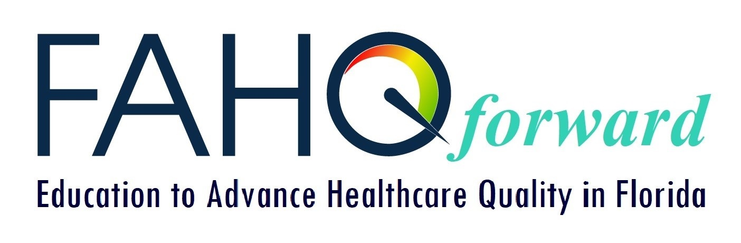

**April 30 – May 3, 2019**

**Embassy Suites by Hilton Orlando,**

**Lake Buena Vista South**

**4955 Kyngs Health Road**

**Kissimmee, Florida**

**A palm tree in front of a building

Description generated with very high confidence**

***SPONSOR AND EXHIBITOR PACKET***

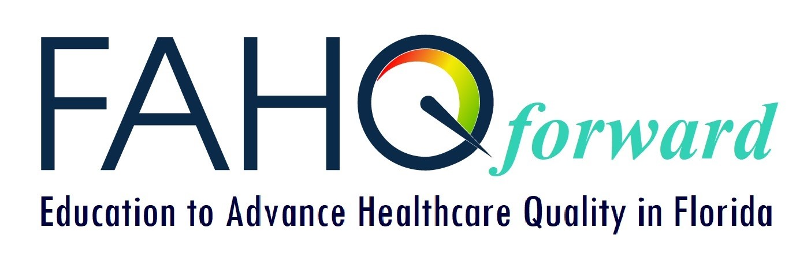

# GREETINGS

# 

# FLORIDA ASSOCIATION FOR HEALTHCARE QUALITY

FAHQ is focusing on moving forward to advance healthcare quality in Florida through education in the field. The annual conference is our premier education event.

For those who supported in past years, we thank you again and hope that you are available to join us to promote your products and services at our annual event. For those of you unable to join last year, we hope that you can join us this year. And for those of you just now considering sponsorship – thank you, we hope you join us this year.

The 2019 FAHQ Annual Conference will again be held close to the Orlando attractions as our customers have requested. The Exhibit Hall will be open on to attendees on Thursday and Friday, May 2-3. New sponsorship opportunities this year include a Thursday FAHQ Member Luncheon and Friday Networking Breakfast. Or choose to sponsor the Pre-Conferences or CPHQ Review.

We look forward to working with you to provide another successful annual conference.

On behalf of the Conference Planning Team, and FAHQ members, we thank you,

***Irv Koehler, Sponsor Coordinator***

[koehlerqgllc@aol.com](mailto:koehlerqgllc@aol.com) 423-421-5492

***Jessica Ferraro, Conference Planning Team Leader***

**A Very Special Thank You to the FAHQ 2018 Annual Conference Sponsors and Exhibitors: **

|  |  |
| --- | --- |
| http://www.fahq.org/wp-content/uploads/2018/03/dnv.jpg  **Diamond Sponsor | Speaker |**  **President’s Reception |Exhibitor** | https://www.fahq.org/wp-content/uploads/2018/03/EarlySense-300x105.jpg  **Bronze Sponsor | Exhibitor |**  **Education Raffle Money Tree** |
| http://www.fahq.org/wp-content/uploads/2018/03/QI_Macros.png  **Sterling Sponsor | Raffle Prize |**  **Conference Attendee Gifts** | http://www.fahq.org/wp-content/uploads/2018/03/CFMA.jpg  **Speaker | Exhibitor** |
| https://www.fahq.org/wp-content/uploads/2018/03/deb_med.jpg  **Exhibitor** | **See more of our outstanding sponsors and exhibitors from past conferences at**  **www.FAHQ.org** |

**ANNUAL**

**CONFERENCE**

**SPONSORSHIP**

**ALL SPONSORS RECEIVE:**

Recognition (signage and sponsor profile in handouts) at the annual conference

Sponsor name/logo on Conference Sponsor page of FAHQ website for no less than 4 months

Sponsor name with website link published in Florida Quality News

**CONFERENCE SPONSOR** **- $10,000**

Sponsor name and logo **exclusively** on main conference signage as our presenting sponsor

Designated member of sponsoring organization named as **Honorary Chairperson of Conference**

Article on sponsor organization in the FAHQ Quality News Conference Edition.

Sponsor name with website link on FAHQ website while promoting conference and in summary as a past conference

One free Exhibitor booth in Exhibitor Hall, if desired (guaranteed if Sponsor agreement completed before February 15, 2019)

3 free registrations for Conference AND 3 free pre-conference workshop registrations

**SPEAKER SPONSOR - $5,000**

Clear recognition of sponsorship of specific speaker by signage and introduction

One free Exhibitor booth in Exhibitor Hall, if desired (guaranteed if Sponsor agreement completed before February 15, 2019)

2 free registrations for Conference OR pre-conference workshops

**DIAMOND SPONSOR - $4,000**

**There are three separate, exclusive Diamond opportunities**

* **CPHQ REVIEW COURSE SPONSOR (April 30 – May 1, 2019)**

Company is recognized as **exclusive** sponsor of CPHQ Review Course (signage) with signage and introduction if present, or acknowledgement if not present.

* **PRE-CONFERENCE SPONSOR (May 1, 2019)**

Company is recognized as **exclusive** sponsor of Pre-Conference Workshops (signage)

and the Networking Luncheon held during the pre-conference period

* **FAHQ ANNUAL MEETING LUNCHEON (May 2, 2019)**

Company is recognized as **exclusive** sponsor of President’s Reception at Conference with signage and introduction at Reception if present or acknowledgement if not.

**These benefits apply to all Diamond opportunities:**

One free Exhibitor booth in Exhibitor Hall, if desired (guaranteed if Sponsor agreement completed before February 15, 2019)

2 free registrations for Conference OR pre-conference workshops

# FLORIDA ASSOCIATION FOR HEALTHCARE QUALITY

**ANNUAL CONFERENCE SPONSORSHIP**

**OPPORTUNITIES**

**ALL SPONSORS RECEIVE:**

Recognition (signage and sponsor profile in handouts) at the annual conference

Sponsor name/logo on Conference Sponsor page of FAHQ website for no less than 4 months

Sponsor name with website link published in Florida Quality News

**CONFERENCE SPONSOR** **- $10,000**

Sponsor name and logo **exclusively** on main conference signage as our presenting sponsor

Designated member of sponsoring organization named as **Honorary Chairperson of Conference**

Article on sponsor organization in the FAHQ Quality News Conference Edition.

Sponsor name with website link on FAHQ website while promoting conference and in summary as a past conference

One free Exhibitor booth in Exhibitor Hall, if desired (guaranteed if Sponsor agreement completed before February 15, 2019)

3 free registrations for Conference AND 3 free pre-conference workshop registrations

**SPEAKER SPONSOR - $5,000**

Clear recognition of sponsorship of specific speaker by signage and introduction

One free Exhibitor booth in Exhibitor Hall, if desired (guaranteed if Sponsor agreement completed before February 15, 2019)

2 free registrations for Conference OR pre-conference workshops

**DIAMOND SPONSOR - $4,000**

**There are three separate, exclusive Diamond opportunities**

* **CPHQ REVIEW COURSE SPONSOR (April 30 – May 1, 2019)**

Company is recognized as **exclusive** sponsor of CPHQ Review Course with signage and introduction if present, or acknowledgement if not present.

* **PRE-CONFERENCE SPONSOR (May 1, 2019)**

Company is recognized as **exclusive** sponsor of Pre-Conference Workshops with signage and introduction if present, or acknowledgement if not present.

* **FAHQ ANNUAL MEETING LUNCHEON (May 2, 2019)**

Company is recognized as **exclusive** sponsor of Thursday Luncheon at Conference with signage and introduction at Reception if present or acknowledgement if not.

**These benefits apply to all Diamond opportunities:**

One free Exhibitor booth in Exhibitor Hall, if desired (guaranteed if Sponsor agreement completed before February 15, 2019)

2 free registrations for Conference OR pre-conference workshops

# FLORIDA ASSOCIATION FOR HEALTHCARE QUALITY



**ANNUAL CONFERENCE SPONSORSHIP**

**OPPORTUNITIES**

**GOLD SPONSOR- $2,500**

**There are two separate, exclusive Gold opportunities**

* **Exclusive** sponsor of FAHQ conference tote bag (signage and imprint on bag with FAHQ imprint)
* **Exclusive** sponsorFAHQ Networking Breakfast on Friday(signage and introduction)

One free Exhibitor booth in Exhibitor Hall, if desired (guaranteed if Sponsor agreement completed before February 15, 2019)

2 free registrations for Conference OR pre-conference workshops

**SILVER SPONSOR- $1,500**

**There are two Silver opportunities available:**

* **Exclusive** sponsor of Conference breaks Thursday and Friday
* **Exclusive** sponsor of Breakfast Thursday

One free Exhibitor booth in Exhibitor Hall, if desired (guaranteed if Sponsor agreement completed before February 15, 2018)

1 free registration for Conference

**BRONZE SPONSOR - $1,000**

**Event opportunity for our Bronze sponsor(s):**

* **Grand Prize Raffle ($500 money tree)**

One free Exhibitor booth in Exhibitor Hall, if desired (guaranteed if Sponsor agreement completed before February 15, 2018)

1 free registration for Conference

# FLORIDA ASSOCIATION FOR HEALTHCARE QUALITY



**ANNUAL CONFERENCE EXHIBITORS**

# FLORIDA ASSOCIATION FOR HEALTHCARE QUALITY

**This is a 2-day opportunity to be an Exhibitor at our Conference.** Exhibit days are Thursday and Friday, May 2-3. Dedicated Exhibitor times include Breakfast with Exhibitors and 30-minute AM and PM breaks - *all held in Exhibitor Hall*. Exhibitors (2 per company) are welcome to join us for lunch these two days to network with attendees in a social environment. The President’s Reception on Wednesday evening provides an opportunity to staff your booth and socialize with attendees, as this event is also held in Exhibitor Hall.

**Exhibitor Fee is $500 per company exhibiting. Booth sharing is not permitted.**

**Exhibitor fee includes:**

* Exhibit booth: space in Exhibitor Hall includes one six-foot-long table and two chairs
* Breakfasts, breaks and Thursday lunch are included for 2 people
* Company name or logo listed on **Conference Signage** at Exhibitor Hall
* Company name and contact information is listed on Conference Exhibitor page on **FAHQ website for at least 2 months prior to conference** (**early commitment extends this time**)
* Brief company description included in **FAHQ Conference folder**
* Company name and contact link is listed in **Florida Quality News** prior to the Conference in segment recognizing Our Supporters
* Company name and contact information is listed in **Special Conference Edition** of Florida Quality News following the conference
* Registration to attend Annual Conference and receive continuing education credit is included for one attendee; **discounted rate of $200 (to include meals, and breaks) is available for any additional persons per exhibit.** You can use this option to register an employee **or a client** for the 2-day Conference. Regular registration rates apply for the pre-conference programs.
* FAHQ will hold a **Drawing** to “reward” attendees who visit all our Exhibitors

Set up on Wednesday, May 1 from 12 noon to 7:30 PM

Exhibiting starts Thursday, May 2 and Friday, May 3 at 7:00 AM.

Exhibits close at 10:30 AM on Friday, May 3.

Teardown must be completed by noon Friday, May 4. Conference

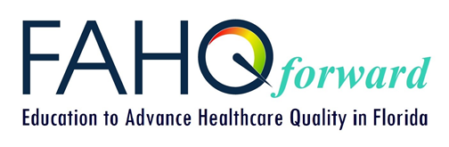

**FLORIDA ASSOCIATION FOR**

**HEALTHCARE QUALITY**

**Sponsor/Exhibitor Letter of Agreement**

**FAHQ 2019 Annual Conference**

**April 30 – May 3, 2019 at Embassy Suites by Hilton, Lake Buena Vista South, Kissimmee, FL**

**SPONSOR/EXHIBITOR INFORMATION**

Organization:

Service/Product:

Billing/Scheduling Contact Name:

Billing/Scheduling Contact Title:

Phone: _________________ Email:

Street Address:

City/State/Zip:

Name(s) of Representative(s) Attending (note Sponsor/Exhibitor descriptions for approved # to attend):

(1)

Attending: Pre-Conference Workshop Conference Booth only

(2)

Attending: Pre-Conference Workshop Conference Booth only

(3)

Attending: Pre-Conference Workshop Conference Booth only

**PLEASE INDICATE SPONSOR/EXHIBIT OPPORTUNITY YOU ARE SUPPORTING:**

|  |  |  |  |
| --- | --- | --- | --- |
|  | Type | Specific Opportunity | Cost |
|  | Presenting Sponsor | N/A | $10,000 |
|  | Speaker Sponsor | Speaker Name:  ________________________ | $5,000 |
|  | Diamond Sponsor | ___ CPHQ Review Course  ___ Preconference  ___ Annual Meeting Luncheon | $4,000 |
|  | Gold Sponsor | ___ Conference Tote Bags  ___ Friday Networking Breakfast | $2,500 |
|  | Silver Sponsor | ___ Conference Breaks  ___ Thursday Breakfast | $1,500 |
|  | Bronze Sponsor | ___ Raffle Money Tree | $1,000 |
|  | Sponsor Exhibit Booth – please select if you are a sponsor at one of the above levels and wish to exhibit | N/A | No Charge |
|  | Exhibit Booth Only | N/A | $500 |

The Sponsor agrees to release and hold harmless Embassy Suites by Hilton, Lake Buena Vista South and FAHQ, and their officers, representatives, agents and directors from all liability whatsoever for any loss, damage, or injury resulting directly or indirectly from any cause whatsoever in connection with this educational event and execution of this Agreement.

**Authorized signature**: _________________________________________ Date: _________________

To ensure your request for sponsorship is understood and billed correctly, the FAHQ process includes approval by our Sponsor Coordinator prior to your full registration and payment.

Please complete this form and email to: Irv Koehler, FAHQ Conference Sponsor Coordinator

Phone: 423-421-5492 Email: [koehlerqgllc@aol.com](mailto:koehlerqgllc@aol.com)

**SUBMISSION DEADLINE IS FEBRUARY 15, 2019**

**(Sponsorship requests after the deadline will be considered on a space available basis)**

Once the agreement is approved, you will receive an email with a link taking you into our registration system to pay. You may pay online using a credit card or offline by mailing a check. Instructions will be provided within the registration system.

**Thank you for your support of our FAHQ Annual Conference.**